**AN INDUSTRIAL AUTOMATION & CONTROLS COMPANY**

***EXCEL TECHNOLOGICAL SERVICE***

**HEAD OFFICE:**

**235, S BLOCK**

**St. 11, L.C.C.H.S**

**Lahore-54796, Pakistan.**

**Ph: 042-5734740-1**

**Fax: 042-5734742**

**E-mail: ets@brain.net.pk**

**BRANCH OFFICE:**

**Mr. Naveed A. Khan 54-C-II, Satelite Town Rawalpindi.**

**Ph: 051-427162-453739**

**Fax: 051-418418**

**LAISION OFFICE:**

**Mr. A.U. Mirza**

**615-Park Avenue 24-A**

**P.E.C.H.S. Block # 6 Shahrah-a-Faisal-76400 Karachi.**

**Ph: 021-4531794**

**021-4549024**

**To Whom It May Concern**

This is certifying that Mr. <Name> S/O <fname> NIC No. <CNIC> has worked in Excel Technological Services, Lahore as an <Designation> in our Services Department from <From2> to <To2>.

We are completely satisfied with is performance. We thank him for the service he rendered to the company and we wish him success in his future career and we highly recommend him. This certificate is issued as token of appreciation for his services.

Yours Truly,

*for* Excel Technogical Services

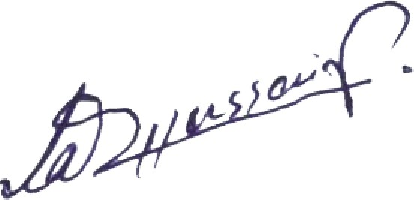

**Admin Manager ETS**

